**Airport Information for EURIPA colleagues**

Lincoln is easily accessible, and the University is just a 5 minute walk from the city centre Train and Bus Stations.

There are a number of airports that can be used together with an onward rail connection. The document below lists the different arrival airports and the airlines using them, and the best method of getting to Lincoln from the airport.

**Arriving at London Airports**

**Heathrow**

Heathrow is the largest London airport and is serviced by the major airlines.

Connections and onward travel: [Travelling From Kings Cross to Heathrow Airport | Heathrow | Heathrow](https://www.heathrow.com/transport-and-directions/by-rail-or-train/kings-cross)

Heathrow Express : [Kings Cross to Heathrow Airport | Heathrow Express Train](https://www.heathrowexpress.com/kings-cross-to-heathrow-airport-by-train#/)

London Underground: Take the Piccadilly Line to London King’s Cross

**Luton**

Luton is serviced by a number of the budget airlines that fly to Europe such as EasyJet, WIZZ, Ryan Air, Tui, and Sun Express.

Connections and onward travel: <https://www.london-luton.co.uk/to-and-from-lla/going-south-beyond-london>

To travel via London take the airport shuttle to Luton Parkway and then catch one of the frequent trains to London St. Pancras. Walk to London King’s Cross from St. Pancras. The train stations are next to each other and the walk between the two stations is approximately 3 minutes. Trains from London King’s Cross to Lincoln can be booked direct or you can also choose trains with changes at Peterborough or Newark Northgate.

**Stanstead**

Stanstead is serviced by a number of the budget airlines that fly to Europe such as Jet2.com, EasyJet, Ryan Air, Tui, Eurowings, Air Corsica, as well as British Airways.

Connections and onward travel: Trains to Lincoln can be taken from Stanstead without having to go into London. These trains travel via Cambridge and Peterborough, where you have to change.

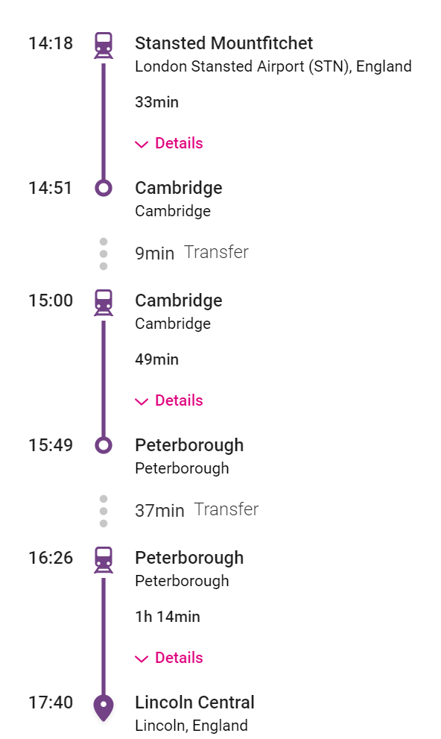

You can also travel into central London and out again directly to Lincoln, from Kings Cross. [London Stansted Airport To Central London | London Stansted Airport](https://www.stanstedairport.com/getting-to-and-from/stansted-to-london/)

**Gatwick**

Gatwick is serviced by a number of the budget airlines that fly to Europe such as Aer Lingus, Aegean, airBaltic, Air Europa, Croatia Airlines, EasyJet, Ryan Air, Norse Airlines, Tui, WIZZ and British Airways.

Connections and onward travel: <https://www.gatwickairport.com/transport-options/to-from-london.html>

Trains to Lincoln from Gatwick will usually require a change in London at either London St Pancras or London King’s Cross. If travelling to London St Pancras you will then need to transfer to London King’s Cross for trains to Lincoln. Walk to London King’s Cross from St. Pancras. The train stations are next to each other and the walk between the two stations is approximately 3 minutes. Trains from London King’s Cross to Lincoln can be booked direct or you can also choose trains with changes at Peterborough or Newark Northgate.

**Arriving at Midlands Airports**

**Birmingham**

Birmingham airport is located 10 miles south of the city of Birmingham, which is in the West Midlands, and is approximately 73 miles from Lincoln by train. Birmingham airport is serviced by a number of the budget airlines that fly to Europe such Aer Lingus, Brussels Airlines, EasyJet, Emerald Airlines, Eurowings, KLM Royal Dutch Airlines, Lufthansa, Pegasus Airlines, Ryan Air, Tui, Vueling and WIZZ. A list of airlines is available in the following link: <https://www.birminghamairport.co.uk/at-the-airport/terminal-facilities/airline-directory/>

Flights from Birmingham travel to the destinations in the following link: <https://www.birminghamairport.co.uk/destinations-and-more/where-we-fly/>

Connections and onward travel: Birmingham Airport is directly connected to over 100 towns and cities in the UK via Birmingham International Station and the 'Air-Rail Link' monorail system. The free Air-Rail Link takes two minutes to get to the station and operates between 03:30 and 00:30 hours daily. Trains to Birmingham New Street run frequently from Birmingham International Station. To travel to Lincoln using public transport, take the train from Birmingham International Railway Station to Birmingham New Street Station. Then take a train to Nottingham and change there for a train to Lincoln Central. <https://www.birminghamairport.co.uk/directions-and-transport/by-train/>

Birmingham is the second-largest city in Britain and is the vibrant social, cultural, financial and commercial centre of the Midlands at England’s centre, lying north of the Cotswolds and Shropshire hills and is approximately 20 miles from Stratford Upon Avon, the historic birthplace of William Shakespeare.

**East Midlands Airport**

East Midlands Airport is located 13 miles to the south of Nottingham and close to the cities of Derby and Leicester. East Midlands Airport is serviced by a number of the budget airlines that fly to Europe such as Aer Lingus, Jet2.com, Ryanair and TUI. A list of airlines is available in the following link: [Airline Contact Details | East Midlands Airport](https://www.eastmidlandsairport.com/flight-information/flight-operators/) . Flights from East Midlands Airport travel to over 90 destinations

Connections and onward travel:

East Midlands Airport is accessible by train with East Midlands Airport Parkway just 5 miles from the airport terminal. The Nottsbus On Demand service connects the train station to East Midlands Airport. [Travelling by Train | East Midlands Airport](https://www.eastmidlandsairport.com/getting-to-and-from/by-train/). Trains to Lincoln may mean changing at Nottingham, but some services rundirect from East Midlands Airport Parkway to Lincoln as per the example routes below.

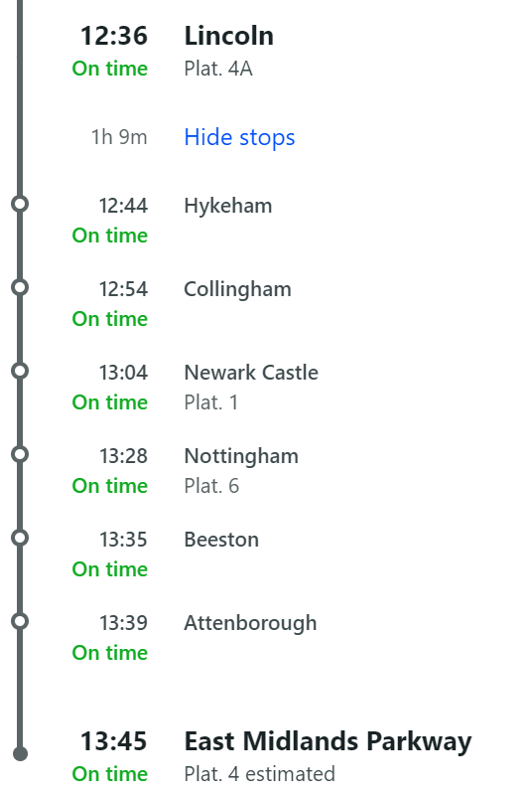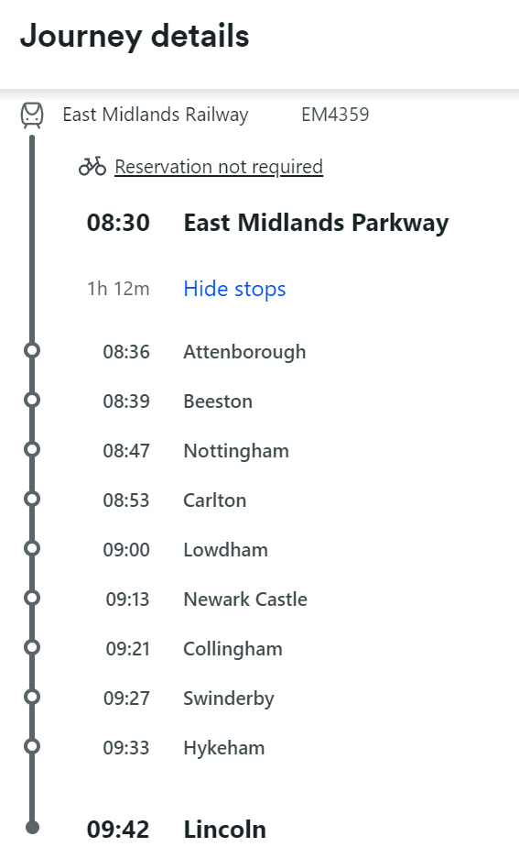

Alternatively, using public transport, you can take a bus/taxi from the airport to Nottingham Railway Station (12 miles) and take the 55 minute direct train to Lincoln Central Station.

**Humberside Airport**

Humberside Airport is located 30 miles northeast of Lincoln. KLM is one of the main flight operators that flies out of the airport to Europe. KLM offers flights from Humberside Airport (HUY) to Amsterdam Schiphol Airport (AMS) 7 days a week. The route is operated by KLM Cityhopper. Further details available in the following link: [Airlines, Tour Operators & Private Charter - Humberside Airport](https://www.humbersideairport.com/routes-and-destinations/airlines-tour-operators-private-charter/)

Connections and onward travel:

Humberside Airport is mainly accessible via road networks although the nearest railway station is Barnetby Station which is located just three miles from the airport. Example routes to Lincoln are shown below. It is worth checking the times that trains run as this is a district line rather than a mainline service. The easiest way to travel to Lincoln from Humberside Airport is by road. At Humberside Airport you will find two major car rental companies as well as a 24-hour taxi company. Further details available here: [How to Get to Lincoln by Air | Visit Lincoln](https://www.visitlincoln.com/travel-tools/lincoln-by-air/)

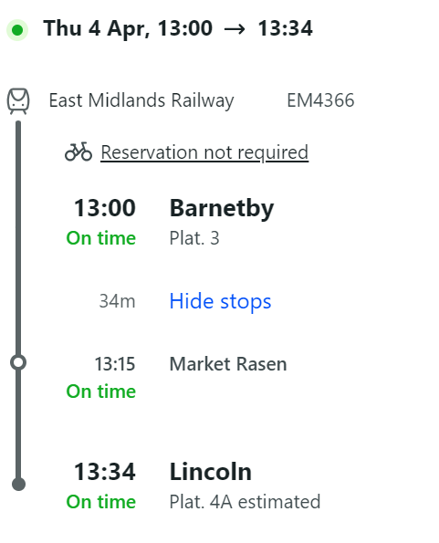 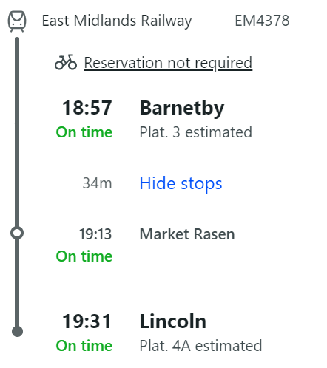

**Arriving at Manchester Airport**

Manchester airport is located 92 miles west of Lincoln. Travel time to Lincoln is 135 minutes by road / 165-210 minutes by rail

To travel to Lincoln using public transport, you take the train from Manchester Airport Station to Manchester Piccadilly Station. Then take a train to either Sheffield or Doncaster and then change to take a train to either Sheffield or Doncaster where you change for a train to Lincoln Central.

**Arriving at Leeds Bradford International Airport**

Leeds Bradford International Airport is located 82 miles northwest of Lincoln. Travel Time to Lincoln is 110 minutes by road / 165-210 minutes by rail

To travel to Lincoln using public transport, take the train from Leeds Bradford Airport to Doncaster or York Station. Then take on onward train to Lincoln Central, please note you may have an additional change at Nottingham or Newark Northgate depending on your chosen route.

**Trainlines**

There are multiple train booking sites for UK rail journeys but the key ones for Lincoln are: [TheTrainline.com](https://www.thetrainline.com/?origin=urn%3Atrainline%3Ageneric%3Aloc%3AKGX6121gb&destination=urn%3Atrainline%3Ageneric%3Aloc%3ALCN6340gb&utm_medium=cpc&utm_campaign=UK_All_Routes_EC_Tier%203_BSH15E8&utm_source=bing&gclid=75377ec283a31cd8c10918cfc717e584&gclsrc=3p.ds) , [LNER](https://www.lner.co.uk/our-destinations/popular-routes/london-kings-cross-to-lincoln-trains/) , [northernrailway.co.uk](https://www.northernrailway.co.uk/journey-planner/london-kings-cross-to-lincoln) ,

Further information on train travel in the UK is available here: [National Rail](https://www.nationalrail.co.uk/live-trains/details/?sid=202404036782049&type=departures&targetCrs=KGX&filterCrs=LCN)

Please use **Lincoln Central** as your **destination**.

If you do go into London you will need to use the London Underground.

London Tube: [Tube - Transport for London (tfl.gov.uk)](https://tfl.gov.uk/modes/tube/)

Tube Map – download a copy here: <https://content.tfl.gov.uk/large-print-tube-map.pdf>

**Car Rental**

All the airports listed have car rental available which you can book prior to your arrival in the UK. Providers vary locally, examples of some of the larger UK providers include Enterprise, Hertz and Avis. Please ensure that you check you have the right documentation needed prior to booking so that you can drive in the UK.

By Car

If driving by car, please use the postcode LN6 7DQ to locate us, we are easily accessible by road via the A46/A15 which link us to the main UK motorway network. For more about transport links around campus including parking:

<https://bpb-eu-w2.wpmucdn.com/blogs.lincoln.ac.uk/dist/5/3685/files/2023/12/City-Centre-Parking-Dec-23.pdf>